**Bucks Bulletin Board**



**CLASSROOM TO CAREERS**

Careers newsletter for families | December 2024

Mollie’s Diner in Faringdon is hosting monthly masterclasses for groups of up to 10 students, who’ll get to make Mollie's famous milkshakes and learn about the hospitality industry. To reserve a spot, email [rebecca.lester@mollies.com.](mailto:rebecca.lester@mollies.com)

Interested in working in healthcare? Secure your place at Buckinghamshire Healthcare NHS Trust’s after-school talks about careers in [psychology](https://www.tickettailor.com/events/buckinghamshirehealthcarenhstrust/1415138) (13th

Feb) and [biomedical science](https://www.tickettailor.com/events/buckinghamshirehealthcarenhstrust/1487691) (13th Mar) at Stoke Mandeville Hospital.

Richmond, Uxbridge and Harrow Colleges have partnered with the Massachusetts Institute of Technology (MIT) to launch a [groundbreaking national](https://www.hruc.ac.uk/mit-program/a-national-innovation-competition.html) [competition](https://www.hruc.ac.uk/mit-program/a-national-innovation-competition.html) for secondary school students on the theme ‘sustainable impact’.

# The perfect gift

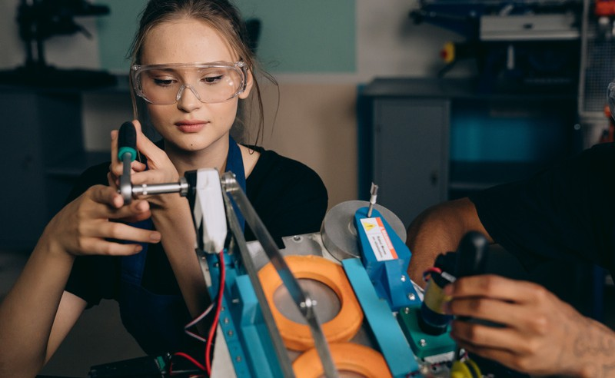Scoffed all your advent calendar chocolate already? Don't worry, there are enough treats in this month’s newsletter to make up for it. Starting with exclusive online events hosted by top employers, including [IBM, Technology and Business](https://uptree.co/events/ibm/1062099460/) (11th Dec), [Females in Tech](https://pathwayctm.com/event/accenture-insight-webinar-females-in-tech/) with Accenture (17th Dec), and a Merky Books x HSBC collaboration titled  [Can’t We Just](https://www.speakersforschools.org/upcoming-broadcasts/)

[Print More Money ?](https://www.speakersforschools.org/upcoming-broadcasts/) (19th Dec). Merry Christmas!

# University: An insider’s guide to tuition fees

If the government’s recent announcement that university tuition fees will rise in 2025 is causing you stress, we’ve got just the thing to put your mind at ease. Uni Myths Busted has teamed up with the student money experts at Save The Student to reveal [how the changes will (but in most](https://www.unimythsbusted.co.uk/tuition-fees-explained/) [cases won’t) impact you](https://www.unimythsbusted.co.uk/tuition-fees-explained/). And breathe...

# Buckle up



Looking to develop your problem solving, data literacy and presentation skills? Students in Years 10-13 are invited to participate in National Highways’ exciting live career challenge on Wed 11th Dec. The mission, if you accept it, is to advise the company which designs, builds and operates England’s motorways on which parts of the network to prioritise for Wi-Fi connectivity. [Register here.](https://digdata.online/national-highways-career-challenges/)

# Work experience: Make the most of the winter break

We love Christmas, but the bit between Boxing Day and New Year can be a drag if you don’t have something productive to do. Not this year though! Santa’s elves have been up all night collating [the best](https://bucksskillshub.org/career-seeker/resources/supercharge-your-christmas-break) [online work experience courses](https://bucksskillshub.org/career-seeker/resources/supercharge-your-christmas-break) available 24/7.

**All new!**

[**Sign up now**](https://mailchi.mp/amazingapprenticeships.com/vacancies) **to receive the Amazing Apprenticeships monthly vacancies newsletter.**

# Careers: Getting to know De Soutter

The countdown to Bucks Skills Show 2025 is on! Our annual experiential careers fair will be popping up in Stoke Mandeville Stadium on Wednesday 5th and Thursday 6th March, which gives you just under three months to [bag a free ticket](https://www.eventbrite.co.uk/e/bucks-skills-show-2025-tickets-1048666027317) and [get acquainted with our brilliant headline sponsor,](https://bucksskillshub.org/career-seeker/resources/five-things-about-de-soutter)

[De Soutter Medical Ltd](https://bucksskillshub.org/career-seeker/resources/five-things-about-de-soutter). Here are five surprising facts about the local manufacturer of medical devices.

**University: The latest**

**apprenticeship degrees**

**Parents’ corner**

We know it can be difficult engaging young people in education and training, which is why we’re big fans of the [Talking Futures Parents’](https://www.talkingfutures.org.uk/resources/) [Toolkit](https://www.talkingfutures.org.uk/resources/). This free website is packed with activities, videos and more to help you have informed careers conversations with your child.

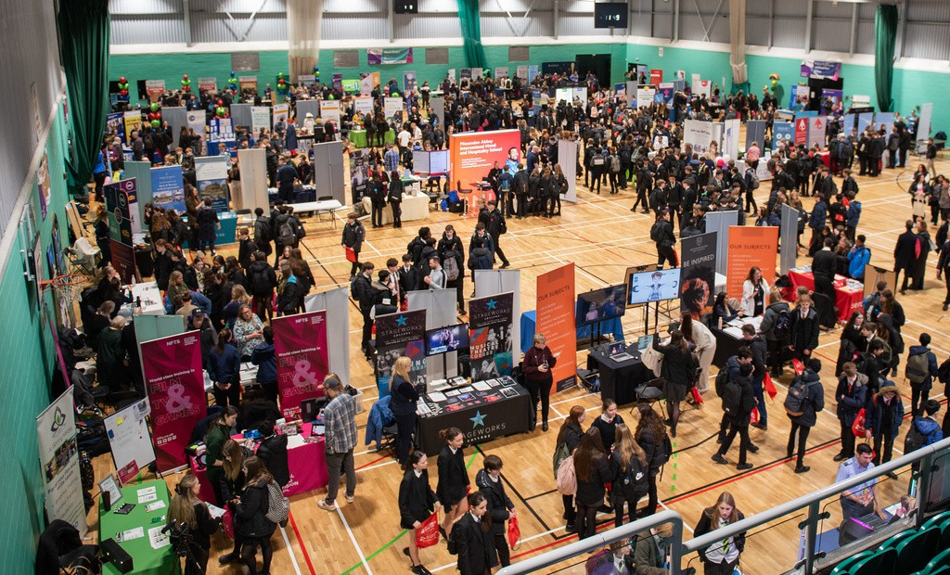

Did you know you can gain a full undergraduate or master’s degree while earning money? You do now! Check out the other [reasons why a degree](https://bucksskillshub.org/career-seeker/resources/degree-apprenticeship-benefits)

a [p prenticeship might be right for you](https://bucksskillshub.org/career-seeker/resources/degree-apprenticeship-benefits), then browse [the latest and greatest](https://bucksskillshub.org/career-seeker/resources/latest-degree-apprenticeships) c [ourses](https://bucksskillshub.org/career-seeker/resources/latest-degree-apprenticeships) available within 45 minutes of Bucks right here.